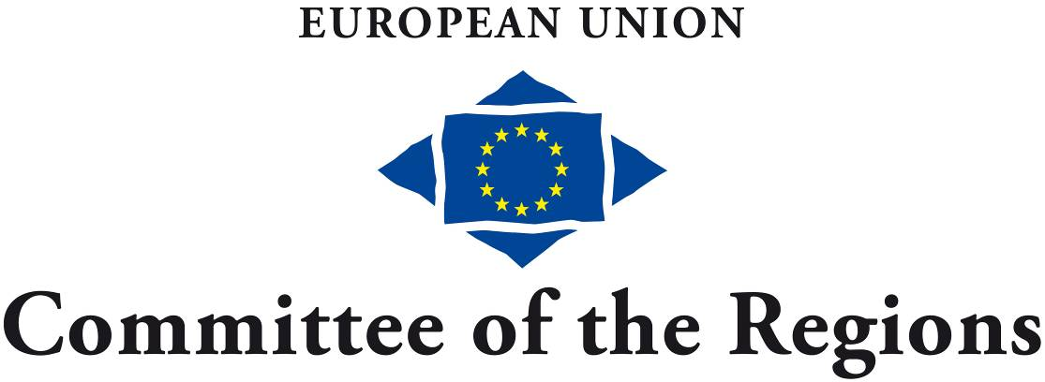
EDUC-V-038
105th plenary session, 30-31 January 2014
— Rue Belliard/Belliardstraat 101 — 1040 Bruxelles/Brussel — BELGIQUE/BELGIË —
Tel. +32 22822211 — Fax +32 22822325 — Internet: http://www.cor.europa.eu
EN

OPINION
European Higher Education in the World

THE COMMITTEE OF THE REGIONS

- emphasises that Member States should develop programmes and support mechanisms - national or targeted at regions in special situations - to assist higher educational institutions at local and regional level in implementing their internationalisation strategies;
- calls on the Commission and the Member States to take all the requisite steps to ensure that implementing internationalisation strategies boosts the potential of regions lagging behind;
- emphasises the importance of the bidirectional nature of mobility, given that mobility must, in line with the principle of inclusive development, be consistent with the interests of both regions of origin and host regions;
- stresses the importance of language skills in all efforts to internationalise higher education and underlines the role of local and regional authorities as facilitators in the acquisition of such skills and emphasises that in a multilingual and multi-ethnic Europe, higher education institutions offering educational opportunities in more than one language, including minority languages, can play a very significant role;
- underlines the need for consultation on as broad a basis as possible in the course of developing strategic partnerships and calls on local and regional authorities to respond as openly and actively as possible to requests for partnership.

Rapporteur

Csaba Borboly (RO/EPP), President of Harghita County Council

Reference document

Communication from the Commission to the European Parliament, the Council, the European Economic and Social Committee and the Committee of the Regions - European Higher Education in the World
COM(2013) 499 final

Opinion of the Committee of the Regions - European Higher Education in the World

I. POLICY RECOMMENDATIONS

THE COMMITTEE OF THE REGIONS

Internationalisation and competitiveness

is pleased that the European Commission attaches great importance to the internationalisation of higher education in the context of implementing the Europe 2020 strategy, and has drawn up proposals for the requisite strategic framework;

agrees that greater internationalisation of higher education is not just essential from the perspective of the Europe 2020 strategy, but can also generally help to put Europe on track for growth in several ways, besides the undeniable local and regional impacts;

with regard to internationalisation, feels it is significant that there have been major developments throughout the history of European higher education, as international experience is an integral part of certain professions and educational courses;

emphasises that in a multilingual and multi-ethnic Europe, higher education institutions offering educational opportunities in more than one language, including minority languages, can play a very significant role, given that in such multicultural environments students can learn at least two European languages, thus helping to make these institutions attractive for mobile foreign students;

stresses, therefore, the importance of language skills in all efforts to internationalise higher education and underlines the role of local and regional authorities as facilitators in the acquisition of such skills;

in terms of internationalising higher education, feels it is vital for Member States and higher education institutions not to overlook European excellence in the field of philosophy, humanities and the arts which has traditionally played a key role in internationalising higher education, and significantly contributes to the competitiveness of the regions in which leading universities in these fields are situated;

agrees that the shared achievements of European higher education do not only reflect innovation, research and curricula, but also the consistent implementation of the Bologna process, the European Credit Transfer and Accumulation System (ECTS), flexible Member State rules on introducing educational systems with joint and double degrees, and the introduction and dissemination of standardised diploma supplements;

sees great potential in the dissemination of best practices and systemic solutions in the European higher educational system to neighbouring and pre-accession countries, not least because this will more effectively facilitate student mobility from those countries to Europe, and give Europe a stronger position in the competition for talent;

particularly agrees that access to innovative digital training and educational opportunities can significantly help to integrate residents of peripheral areas, persons living with disabilities, and other disadvantaged groups in society and in particular in labour markets; in this connection, acquisition of digital skills, development of digital and online materials and curricula boosted by internationalisation, together with the development and recognition of non-formal educational systems, help to enhance competitiveness;

agrees that student, researcher and teaching staff mobility should be a key component of internationalisation strategies, in view of the contribution of teaching staff mobility to knowledge transfer;

Policy coherence

emphasises that it is the task and responsibility of Member States and local/regional authorities to put into practice the Commission's recommendation that local and regional partners need to play a specific role in framing internationalisation strategies, and that they should be given an opportunity to do so;

calls on local and regional authorities to respond as openly and actively as possible to requests for partnership. They should play a proactive role in developing innovative solutions to promote internationalisation, thus helping to enhance the international competitiveness of European higher education, at the same time as unlocking the comparative advantages of their own regions and making them more attractive;

points out that although Member States, when programming CSF funds, can clearly take account of Horizon 2020 and Erasmus+ objectives, the communication under review does not explicitly state this point in connection with internationalisation strategies, despite the fact that cohesion policy together with higher education, research and innovation instruments offer considerable added value insofar as their national, regional and local strategic frameworks also reflect territorial considerations;

emphasises that enabling knowledge transfer from higher educational and research institutions is a key prerequisite for rural development and for competitive agricultural, forestry and fisheries sectors, a fact reflected in the Common Agricultural Policy toolbox for the 2014-2020 programming period. In view of this, when planning and implementing measures to internationalise higher education, it is useful to take account of this potential for synergies at diverse territorial levels to ensure a pioneering role of Europe in this respect;

points out that much still has to be done in many Member States in terms of achieving the R&D expenditure targets set out in the Europe 2020 strategy. However, additional revenue for higher educational institutions arising from internationalisation should not replace or reduce Member State action in this field;

recommends that the planning of objectives and instruments in strategies framed at national, regional and local levels on the basis of partnership could be built on ex-ante territorial impact assessments;

Multilevel partnerships, subsidiarity

is disappointed that the Commission communication does not sufficiently explain the key role played by local and regional authorities in the process of internationalising higher educational institutions. This would have been consistent with the approach embodied in the U-Multirank system, which takes into account inter alia the extent to which higher education institutions are regionally embedded;

is pleased that the Commission has precisely defined the possible levels at which Community intervention is justified, given that internal and external internationalisation are areas in which not only individual Member State action but also EU initiatives are needed, in view of the common goals;

agrees that for their part Member States must provide adequate and appropriate support for the local and regional levels, and that where necessary they should develop broad-based partnerships, not least at regional level. In doing so they can help higher educational institutions to adjust more effectively to the economic, social and administrative needs and potential of a given region;

emphasises the importance of the bidirectional nature of mobility, given that mobility must, in line with the principle of inclusive development, be consistent with the interests of both regions of origin and host regions. Failing this, migration, demographic and competitiveness problems can arise, which are clearly at odds with cohesion and solidarity objectives;

emphasises that the very process of developing and implementing multilevel partnerships in the field of internationalising higher education is a socially innovative one, which can mobilise additional resources in order to achieve the shared objectives set by stakeholders from local and regional authorities, NGOs and the private sector working together in partnership;

emphasises the need for consultation on as broad a basis as possible in the course of developing strategic partnerships. It is particularly important to ensure that individuals belonging to disadvantaged, potentially marginalised groups - on the basis of sexual orientation, or membership of racial, religious, language or ethnic minorities - are not penalised as a result of implementing internationalisation strategies;

Putting the right conditions in place

acknowledges and appreciates the Commission's efforts to date in terms of coordinating, simplifying and making more transparent the various European support options for higher education, innovation and research;

emphasises that Member States should develop programmes and support mechanisms - national or targeted at regions in special situations - to assist higher educational institutions at local and regional level in implementing their internationalisation strategies;

offers its support to the Commission in promoting formulation of decisions and decision-making relating to the internationalisation of higher education, based on research findings and assessments, in particular on analyses of the role played by local and regional authorities and of successful examples of both the modernisation and internationalisation of higher education;

feels that it is not enough for universities and other higher educational institutions only to mention internationalisation issues in their mission statements; rather, regardless of their legal status and their current responsibilities in the field of internationalisation, all higher education institutions should look for the most appropriate solutions in line with their needs, and develop their own governance and planning structures together with channels for cooperation;

feels that steps should be taken to ensure that non-State, private higher educational institutions - either operated by a foundation or in the form of one - should, like their State counterparts, be able to participate in internationalisation processes without any unjustified restrictions, and to enjoy full access to the relevant supporting measures;

points out that in the case of operations, investments and other projects co-financed by the CSF funds, it is important to take account of the need to facilitate greater internationalisation of higher education, considering the needs and realistic potential of higher education institutions;

particularly in the case of candidate countries, recommends that pre-accession and accession funds are also used to encourage the internationalisation of these countries' higher educational institutions;

calls on the Commission and the Member States to take all the requisite steps to ensure that implementing internationalisation strategies boosts the potential of regions lagging behind, and that successfully internationalised higher education institutions include in their internationalisation strategies specific measures to promote knowledge transfer to higher education institutions which currently have less internationalisation potential;

calls for the swift adoption by the Council of the European Commission's proposal for a recast directive concerning the framing of immigration-, migration- and visa-related measures so as to enable specific, flexible, transparent, sufficiently secure, and at the same time efficient, accessible and rapid management of international cooperation on research, innovation and higher education. This should lead to the timely transposition of this legislative instrument by the Member States and its implementation, in cooperation with local and regional authorities.

Brussels, 30 January 2014.

The President
of the Committee of the Regions
Ramón Luis Valcárcel Siso
The Secretary-General
of the Committee of the Regions
Gerhard Stahl

II. PROCEDURE

Title | European Higher Education in the World
Reference(s) | COM(2013) 499 final
Legal basis | Article 165 TFEU
Procedural basis | Optional consultation
Date of Council/EP referral/Date of Commission letter | 11 July 2013
Date of Bureau/President's decision | 25 July 2013
Commission responsible | Commission for Education, Youth, Culture and Research
Rapporteur | Csaba Borboly (RO/EPP)
Analysis | 1 October 2013
Discussed in commission | 13 November 2013
Date adopted by commission | 13 November 2013
Result of the vote in commission  (majority, unanimity) | Adopted unanimously
Date adopted in plenary | 30 January 2014
Previous Committee opinions | Rethinking Education  Erasmus for All  Modernisation of Higher Education  Agenda for new skills and jobs  Europe 2020 flagship initiative Innovation Union  Youth on the Move  The Digital Agenda for Europe  University-Business Dialogue
Date of subsidiarity monitoring consultation | N/A

_____________

CdR 2392/2012 fin.
CdR 400/2011 fin.
CdR 290/2011 fin.
CdR 401/2010 fin.
CdR 373/2010 fin.
CdR 292/2010 fin.
CdR 104/2010 fin.
CdR 157/2009 fin.

